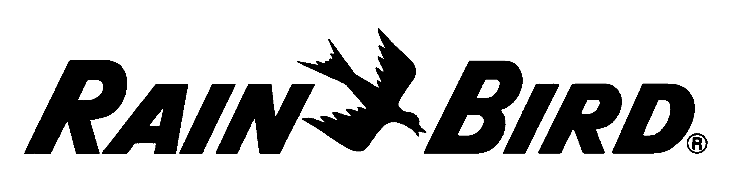 June 2017

Rain Bird® VB Series Valve Boxes
Specifications for 6RND/7RND/10RND/STD/SPR/JMB/MAX Models for Bidding Purposes

VB-6RND SERIES 6” Round Valve Boxes
Valve boxes shall be used as durable, rigid enclosures for valves or other irrigation system components requiring subsurface protection for installation or maintenance. The valve box shall be made of HDPE resin that is resistant to UV light, weather, moisture, and chemical action of soils.

The body shall have two openings molded into the sides to accommodate irrigation pipes.

The valve box shall have corrugated sides.

Lids shall have beveled edges to prevent or minimize potential damage from lawn equipment.

The valve box shall have a standard manufacturer’s limited warranty of five (5) years. The manufacturer’s Professional Customer Satisfaction Policy shall be followed for all warranty requests.

The valve box shall be manufactured by Rain Bird Corporation, Glendora, California.

VB-10RND 10” Round Valve Boxes / VB-7RND 7” Round Valve Boxes

Valve boxes shall be used as durable, rigid enclosures for valves or other irrigation system components requiring subsurface protection for installation or maintenance. The valve box shall be made of structural foam HDPE resin that is resistant to UV light, weather, moisture, and chemical action of soils.

The body shall have knock-outs molded into the sides that can easily be removed. The knock-outs shall remain an integral part of the body unless to run pipes or wires through the valve box.

The valve box shall have corrugated sides. The valve box shall have a stepped feature on the bottom that securely interlocks two boxes together when mated bottom - to- bottom for use in a deep installation.

There shall be no hole in the valve box lid unless the bolt-hole knock-out is removed in order to use the locking bolt. Lids shall have beveled edges to minimize potential damage from lawn equipment. Lids shall be clearly marked with the words "Irrigation Control Valve" molded onto the top. Lids shall have a marking area measuring at least 6" by 2" (15cm by 5cm) that is suitable for branding or other means of identification.

The Valve box shall have an optional purple color lid to identify non-potable water use. The locking bolt, washer, and clip shall be made of stainless steel.

The valve box shall have a standard manufacturer’s limited warranty of five (5) years. The manufacturer’s Professional Customer Satisfaction Policy shall be followed for all warranty requests.

The valve box shall be manufactured by Rain Bird Corporation, Azusa, California.

VB-STD Standard / VB-SPR Super Jumbo / VB-MAX Maxi Jumbo Series Valve Boxes

Valve boxes shall be used as durable, rigid enclosures for valves or other irrigation system components requiring subsurface protection for installation or maintenance. The valve box shall be made of structural foam HDPE resin that is resistant to UV light, weather, moisture, and chemical action of soils.

The standard rectangular body shall have knock-outs molded into the sides that can be readily removed. The knock-outs shall remain an integral part of the body unless removed to run pipes or wires through the valve box.

The valve box shall have corrugated sides. Rectangular valve boxes shall have a grooved feature on one side, just below the lid at the top of the box, for inserting a shovel blade or other prying tool to provide easy lid removal. This is useful following compaction of the surrounding soil or after the eventual accumulation of thatch over the valve box.

The valve box shall have a flange base to allow for increased stabilization and load strength, eliminating the need for blocks.

STD Extension models shall have vertical ribs inside that make them capable of being mounted directly over the top of another box.

Boxes shall have a stepped feature on the bottom that securely interlocks two boxes together when mated bottom-to-bottom for use in a deep installation.
There shall be no hole in the valve box lid unless the bolt-hole knock-out is removed in order to use the locking bolt. Lids shall have beveled edges to minimize potential damage from lawn equipment. Lids shall be clearly marked with the words “Irrigation Control Valve” molded onto the top. Lids shall have a marking area measuring at least 6” by 2” (15cm by 5cm) that is suitable for branding or other means of identification.
The locking bolt, washer, and clip shall be made of stainless steel.

The Valve box shall have an optional purple color lid to identify non-potable water use

The valve box shall have a standard manufacturer’s limited warranty of five (5) years. The manufacturer’s Professional Customer Satisfaction Policy shall be followed for all warranty requests.

The valve box shall be manufactured by Rain Bird Corporation, Azusa, California.

VB-JMB Jumbo Series Valve Boxes

Valve boxes shall be used as durable, rigid enclosures for valves or other irrigation system components requiring subsurface protection for installation or maintenance. The valve box shall be made of structural foam HDPE resin that is resistant to UV light, weather, moisture, and chemical action of soils.

The jumbo rectangular body shall have knock-outs molded into the ends that can be readily removed. The knock-outs shall remain an integral part of the body unless removed to run pipes or wires through the valve box.

The valve box shall have a flange base to allow for increased stabilization and load strength, eliminating the need for blocks.

The valve box shall have corrugated sides. Rectangular valve boxes shall have a grooved feature on one side, just below the lid at the top of the box, for inserting a shovel blade or other prying tool to provide easy lid removal. This is useful following compaction of the surrounding soil or after the eventual accumulation of thatch over the valve box.

Extension models shall have vertical ribs inside that make them capable of being mounted directly over the top of another box.

Boxes shall have a stepped feature on the bottom that securely interlocks two boxes together when mated bottom-to-bottom for use in a deep installation.
There shall be no hole in the valve box lid unless the bolt-hole knock-out is removed in order to use the locking bolt. Lids shall have beveled edges to minimize potential damage from lawn equipment. Lids shall be clearly marked with the words “Irrigation Control Valve” molded onto the top. Lids shall have a marking area measuring at least 6” by 2” (15cm by 5cm) that is suitable for branding or other means of identification.

The locking bolt, washer, and clip shall be made of stainless steel.

The Valve box shall have an optional purple color lid to identify non-potable water use

The valve box shall have a standard manufacturer’s limited warranty of five (5) years. The manufacturer’s Professional Customer Satisfaction Policy shall be followed for all warranty requests.

The valve box shall be manufactured by Rain Bird Corporation, Azusa, California.

