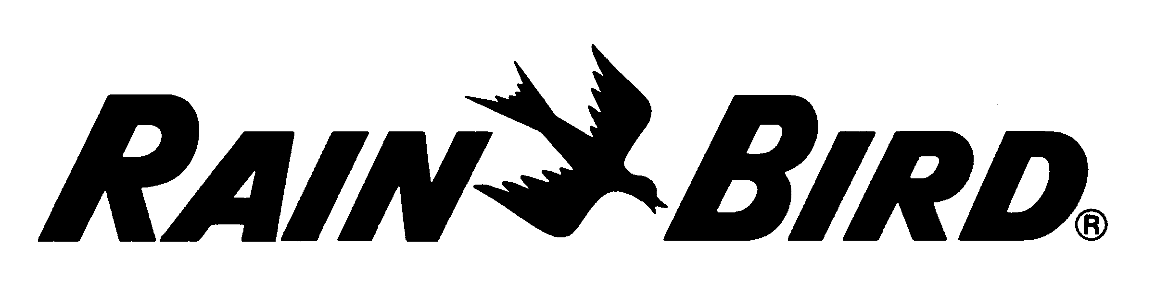 August 2011

Rain Bird® Decoder- Based System
Specifications for Bidding Purposes

Decoder Interface Unit—The interface unit shall be a Rain Bird Decoder Interface “LDI” unit with all solid-state electronic circuitry. It shall provide the necessary interface between the computer and the field decoder units. The interface unit shall provide both communication from the computer out to the field decoder units and “feedback” communication from the field decoder units to the computer. It shall be capable of controlling, over a two-wire path, up to 500 single decoders and up to 1,000 solenoids. The LDI unit shall be complete with 117/220 VAC power supply, cord and a communication cable, which shall be connected between the LDI interface unit and the serial port of the computer. Connect a #6 gauge or larger bare copper ground wire to the chassis of the LDI and route it out and connect it to one rod of the 3-rod grounding grid using a brass clamp.

Field Decoder Units—(decoder-based system)—Furnish and install, where shown on the drawings and/or where directed, Rain Bird Model FD-101, FD201, FD-202, FD-401 or FD-601decoders. All decoder models shall be solid-state electronic circuitry and epoxy potted in a sturdy plastic case suitable for direct burial. Each decoder shall be factory set for specific response code(s) with code number(s) permanently and prominently marked on the decoder case. Also furnish and install in the two-wire path where shown on the drawings and/or where directed, Rain Bird Model LSP-1 surge arrestors. One LSP-1 ground wire shall be attached to the solenoid core tube and the other to a 4' (1.2 m) or longer copper ground rod, installed near the LSP-1 surge arrestor. Grounding equipment shall be installed so as to achieve earth ground resistance of 50 ohms or less.

Decoder System Communication Wiring - For multi-station decoders, Rain Bird Maxi Cable shall be used on the sprinkler side of the decoder, between the decoder and between each of the sprinklers associated with the decoder. Individual, single-strand, station wire, used in a station and common wire method, shall not be an acceptable means of wiring sprinklers to the decoder.

All wire, decoders, grounding and surge devices shall be installed according to the manufacturer’s specifications, following the Rain Bird Decoder System Manual. At no time shall the installer deviate from any specification outlined in the design manual without first contacting the irrigation designer for written approval.

