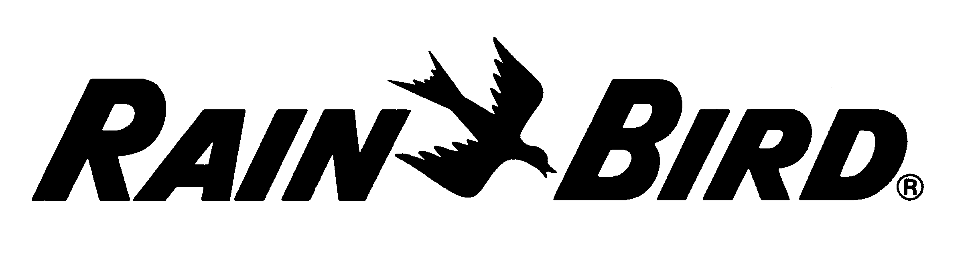

Rain Bird® RainWatch™
Specifications for RainWatch for Bidding Purposes

RainWatch – Rainfall monitoring and response system

A RainWatch™ rainfall monitoring system shall be installed to provide central control response(s) to rainfall. Up to four (4) Rain Bird Tipping Bucket Rain Cans (#F69400) can be installed on a central control system. Tipping Bucket Rain Cans shall be located by the irrigation system designer.

Installation

Rain Cans may be field installed on a 10’ x 1.25” (3.0 m x 3.2 cm) galvanized steel pole or a 10’ x 4” x 4” (3.0 m x 10.1 cm x 10.1 cm) pressure treated wooden post that is properly anchored to an 18” x 24” x 24” (45.7 cm x 61 cm x 61 cm) poured concrete base. Rain Cans may also be installed on the FREEDOM System antenna mast, as shown on the detail drawings, utilizing the existing integrated Rain Can Cable as long as it is located within 60’ (18.3 m) of the central interface (MIM or MDI).

(a) - Installation at a Central Control Location

For central interface installations the integrated Rain Can Cable must be connected to a Pulse Decoder (#F69300) for 2-wire satellite systems, or a Sensor Decoder (#D18700) for decoder systems. The Pulse or Sensor Decoder, as appropriate, shall be installed within 60’ (18.3 m) of the Tipping Bucket Rain Can and adjacent to the appropriate central interface device.

(b) - Installation on a Two Wire Satellite System

For field installations on a 2-wire satellite system the integrated Rain Can Cable must be connected to a Pulse Decoder (#F69300) located inside the nearest satellite controller or other weather resistant enclosure with a supplied MAXI cable. Each Pulse Decoder shall occupy its own channel number on the wire path for central control identification purposes. For distances beyond 60’ (18.3 m) a 2 pair #18 AWG, twisted, shielded cable with drain wire (Paige P7171-D), or equivalent, shall be routed from the satellite/enclosure to an appropriate splice box. The maximum distance between the Rain Can and the Pulse Decoder shall be 300’ (91.5 m). Splice kits shall be UL-Listed, direct bury splice kits conforming to “UL 486D-Direct Burial”.

(c) - Installation on a LINK Satellite System

For field installations on LINK systems the integrated Rain Can Cable must be connected to a Rain Bird Sensor Installation Kit for LINK Systems using Static Sensor Installation Kit (#HA6206) located at a LINK Satellite. An appropriate antenna is required. For locations with good signal strength the Rain Bird Domed Antenna (H60100) shall be mounted to the top of the COM-LINK sensor box contained within the Static Sensor Installation Kit. The antenna gasket shall be sealed with a silicon rubber sealant on both sides to prevent water intrusion into the COM-LINK box. For distant locations or areas with low signal strength a Rain Bird Directional Yagi Antenna (H60130) shall be used.

For distances beyond 60’ (18.3 m), a 2 pair #18 AWG, twisted, shielded cable with drain wire (Paige P7171-D), or equivalent, shall be routed from the Static Sensor Installation Kit box to an appropriate splice box. The maximum distance between the Rain Can and the Sensor Installation Kit shall be 300’ (91.5 m). Splices kits shall be UL-Listed, direct bury splice kits conforming to “UL 486D-Direct Burial”.

(d) - Installation on a Decoder System

For field installations on a Rain Bird Decoder System, the integrated Rain Can Cable must be connected to a Sensor Decoder (#D18700) located at a valve access box within 60’ (18.3 m) of the Rain Can. Splice kits shall be UL-Listed, direct bury splice kits conforming to “UL 486D-Direct Burial”.

(e) - Installation Utilizing Existing Rain Can from a WS-PRO Weather Station

To integrate the rain can of a Rain Bird WS-PRO Weather Station with the central control system, a Rain Shut-Off Cable and Relay, available directly from Campbell Scientific (Logan, Utah (435) 755-0774) shall be used. This cable shall be connected between the Rain Can Wire Harness and Rain Bird MAXI Cable which terminates in a valve access box within 10’ (3.0 m) of the weather station. Depending on the irrigation system control type, the Rain Shut-Off Cable and Relay shall connect to the irrigation control system by one of the following methods:

- For installation on a Rain Bird 2-wire satellite system, the Rain Shut-Off Cable shall be connected to a Pulse Decoder (#F69300) located inside the nearest satellite controller or other weather resistant enclosure with a supplied 14-2 MAXI cable. A direct bury 2-pair #18 AWG, twisted, shielded cable with drain wire (Paige P7171-D), or equivalent, shall be routed from the valve access box at the weather station to the satellite/enclosure. The maximum distance between the Rain Can and the Pulse Decoder shall be 300’ (91.5 m). Splice kits shall be UL-Listed, direct bury splice kits conforming to “UL 486D-Direct Burial”.

- For installation on a Rain Bird LINK satellite system, the Rain Shut-Off Cable must be connected to a Rain Bird Sensor Installation Kit (#HA6203) located at the LINK controller with a supplied 14-2 MAXI cable. A direct bury, 2 pair #18 AWG, twisted, shielded cable with drain wire (Paige P7171-D), or equivalent, shall be routed from the valve access box at the weather station to the Sensor Installation Kit at the LINK controller. The maximum distance between the Rain Can and the Pulse Decoder shall be 300’ (91.5 m). Splices kits shall be UL-Listed, direct bury splice kits conforming to “UL 486D-Direct Burial”.

- For installations on Rain Bird Decoder systems the Rain Shut-Off Cable must be connected to a Sensor Decoder (#D18700) located at the valve access box at the weather station. Splice kits shall be UL-Listed, direct bury splice kits conforming to “UL 486D-Direct Burial”.

All exposed wiring shall be in conduit.

Rain Bird central control system must be operating on version 4.0 or later software.

