**CirrusPRO Turn-Up Procedure**

**Please ensure you submit this completed form to** [**CirrusPROSupport@rainbird.com**](mailto:CirrusPROSupport@rainbird.com) **to have the golfadmin password changed and the installation validated and marked as done.**

**Site: _____________________________________** **Installation Date: ______________**

**Representative Name: ______________________** **Distributor: __________________**

☐ Setup Remote Access in Config-Aid. Below is an example of all that is needed for Remote Access to work properly. Please note that there are only two URLs configured (local host and https://):

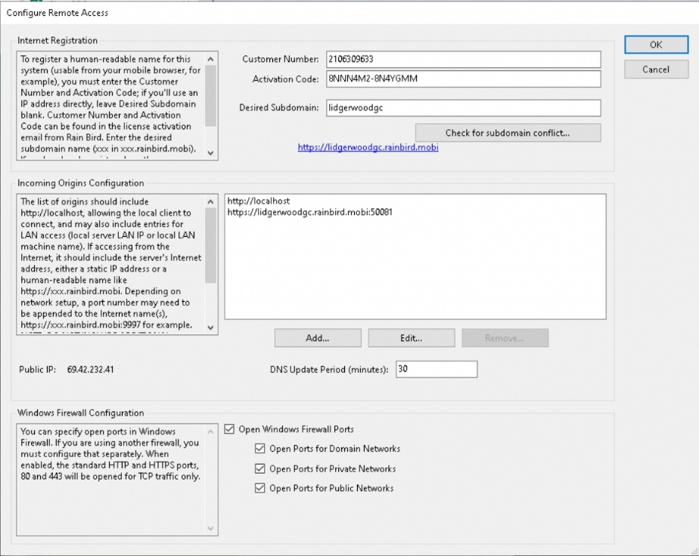

☐ Do port forwarding (if we have access to the router)

☐ Test remote access

Site URL: ______________________________________________________________

☐ Leave the “Remote Access.txt” file on the desktop for I.T. to do the port forwarding (if we don’t have access to the router). Ensure I.T. has been made aware of these instructions. Do not forget to enter the external IP, MAC Address, and computer name.

☐ Connect the interfaces and validate they are working

☐ Connect FREEDOM and test (if applicable)

☐ Connect the Weather Station and test (if applicable)

☐ Verify sensor connectivity and configuration

☐ Create user for the Superintendent

☐ Transition ownership to the Superintendent and ensure the Superintendent is listed as Owner in the list of users.

☐ Ensure battery backup is properly installed

☐ Basic User Training

☐ Adding Users

☐ How to Navigate to Map

☐ Operations from Map

☐ Tree

☐ Multiselect

☐ Diagnostics

☐ Sort and Filter Columns

☐ Batch Edit Feature

☐ Station batch edit

☐ Program batch edit

☐ Schedules batch edit

☐ Programs

☐ Create

☐ Edit

☐ Diagnostics

Representative Signature: ____________________________________________________

Superintendent Name: _______________________________________________________

Superintendent Signature: ____________________________________________________